Lexington Creative Start Children’s Center
2023
Director/Lead Teacher: Patty Brancato- Patrizia@communitiesunitedinc.org
Assistant Director/EFSS: Jeanmarie Peluso - Jeanmarie@communitiesunitedinc.org
Licensed Social Worker – Lisa Higgins-Smite – lisahigginsmith@communiitesunitedinc.org

Classroom 1 - Pre-K Mondays 8:15am- 12:15pm, Tue-Fri: 8:15am-2:15pm
Ms. Patty, Ms. Amber, Ms. Hanna
Classroom 2 -Toddler Room Mondays 8:15am- 12:15pm, Tue-Fri: 8:15am-2:15pm
Ms. Phoebe, Ms. Jillian, Ms. Thallita

CURRICULUM CORNER
The classrooms will be learning about Family and Friends
Learning about family in preschool is important because:
*It provides toddlers and preschoolers with a basic knowledge of family structure and how they are different.
*Children need to learn the importance of family and how family helps in building a strong future.
*Family involvement in early childhood education can extend the experiences that a child has in the classroom to real-world activities that happen in the home.
It increases relationship proximity between parents and child, confidence level of the child, and the child's happiness.”
Class 2 will be reading: Corduroy by Dan Freeman.
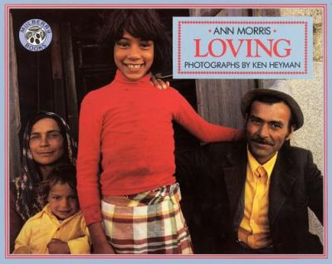
Loving by Ann Morris
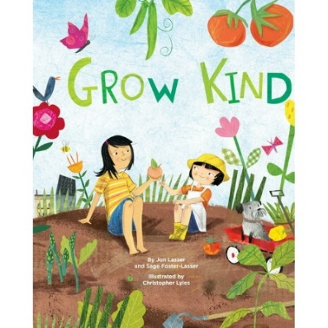
Class 1 will be reading: Grow Kind, by John Lasser
Bear Says Thanks by Karma Wilson and Jane Chapman
Hike and Seek, Nut to Eat by Tracy Gold
Yaffa and Fatima by Shalon and Salaam
Runaway Pumpkins by Teresa Bateman
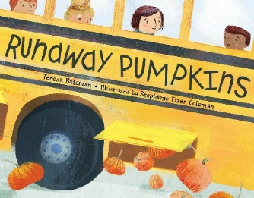
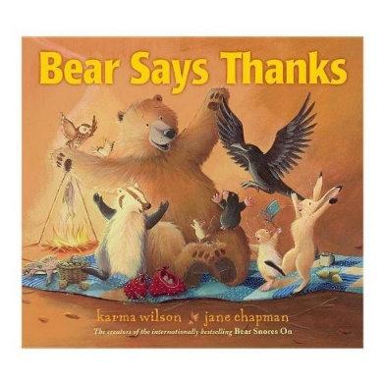
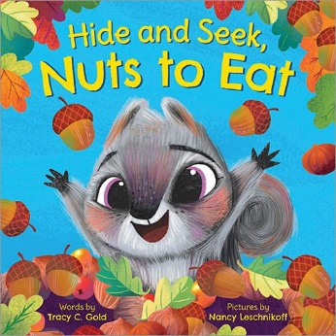
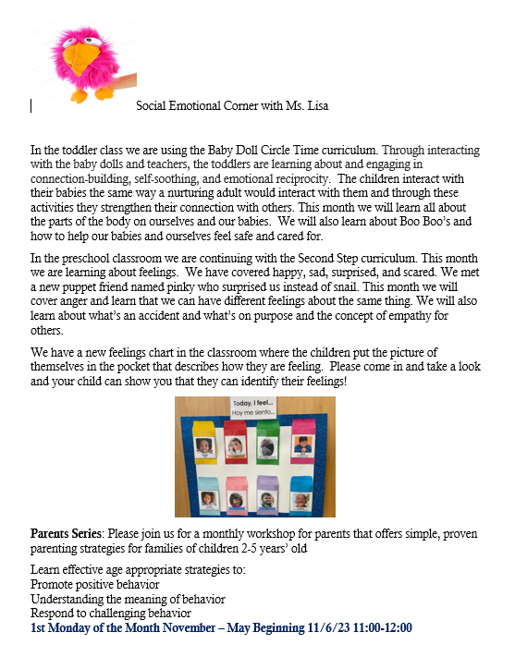

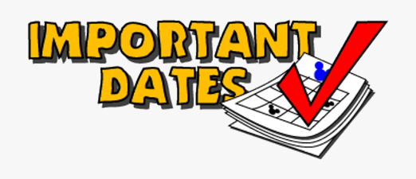
November 10th No School- Veterans Day
November 13th 12:15p Family Event
November 15th 10am. Policy Council Meeting at Central Office
November 15th – Music with Mr. Phil – 11:00 – 12:00 PM
November 20th 11am- 12pm Parent Meeting
November 21st Open Air Market at pick-up
November 22nd- Half Day – early dismissal at 12:00 PM
November 23rd No School- Thanksgiving Day.

November 24th No School- Thanksgiving BREAK.
Our November Family Event:
Join us for a fun Scavenger Hunt on Monday, November 13th at 12:0OPM.
Thank you to everyone who attended our Pumpkin Festival! We are grateful to the church for providing such a fun afternoon for our children, families and staff.
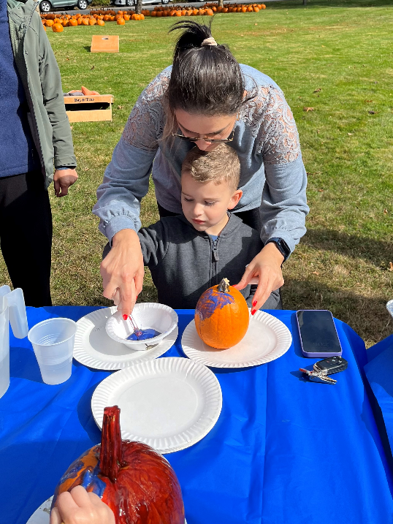
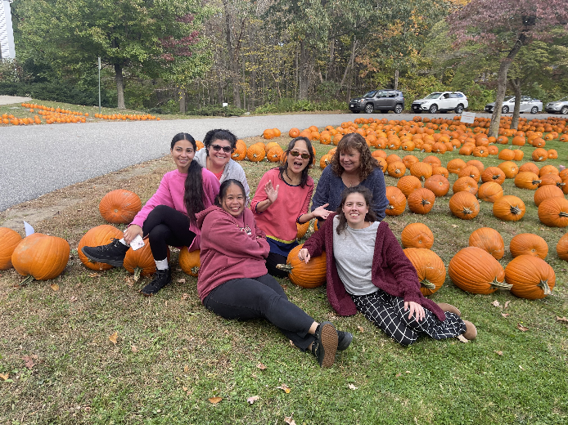

FO

